Richard M. Nixon to George H.W. Bush: The Second Part of the Cold War

Multiple Choice
Identify the choice that best completes the statement or answers the question.

____ 1. Nixon believed that executive privilege
a. | protected him from impeachment proceedings in Congress.
b. | justified his refusal to turn over his taped conversations.
c. | allowed him to participate in a coverup.
d. | enabled him to use federal agencies to attack his political enemies.

Use the following quotation to answer the question.

“We must go forward now together....I believe that truth is the glue that holds government together, not only our Government but civilization itself. That bond, though strained, is unbroken at home and abroad. In all my public and private acts as your President, I expect to follow my instincts of openness and candor with full confidence that honesty is always the best policy in the end. My fellow Americans, our long national nightmare is over.”
--Gerald Ford, August 9, 1974

____ 2. Why do you think Ford made this speech immediately after gaining the presidency?
a. | Nixon’s scandal shook the public’s trust in government.
b. | Ford faced criticism for pardoning Nixon.
c. | Newspaper were not covering economic issues.
d. | Ford needed to successfully fight inflation.

____ 3. Richard Nixon believed that
a. | the public did not want government to address issues such as pollution.
b. | states and communities should give power and resources to federal programs.
c. | Americans had tired of the “big government” of Johnson’s Great Society.
d. | the Office of Economic Opportunity was important for fighting poverty.

____ 4. In the case of United States v. Nixon, the Supreme Court ruled that
a. | Nixon had to turn over tapes containing Oval Office conversations.
b. | executive privilege protected Nixon from having to go to trial.
c. | Nixon had to resign the presidency immediately and go to prison.
d. | the House of Representatives’ Judiciary Committee should investigate Nixon.

____ 5. What was a result of Nixon’s resignation?
a. | Spiro Agnew became President of the United States.
b. | Nixon was put on trial for his crimes at the United Nations.
c. | Americans questioned the system of checks and balances.
d. | Many Americans lost trust in government officials.

____ 6. During his presidency, Gerald Ford
a. | wanted to change Nixon’s foreign policy in Russia.
b. | won public support for pardoning Nixon’s crimes.
c. | selected Paul Volcker to serve as Vice President.
d. | faced high inflation, skyrocketing prices, and rising unemployment.

____ 7. What happened in the 1974 congressional election?
a. | The public showed their disapproval of Nixon’s pardon.
b. | Democrats lost many seats in the House of Representatives.
c. | Republicans lost more than 48 seats in the U.S. Senate.
d. | Republicans won in Ford’s longtime district in Grand Rapids, Michigan.

____ 8. President Ford’s policy toward the Soviet Union focused on
a. | changing Nixon’s foreign policy. | c. | continuing to pursue détente.
b. | protecting human rights. | d. | allowing more political freedoms.

____ 9. President Carter’s response to the Soviet Union’s invasion of Afghanistan in 1979 was to
a. | sign the SALT II treaty. | c. | declare war on the Soviet Union.
b. | impose sanctions on the Soviet Union. | d. | meet with Leonid Brezhnev.

____ 10. Carter’s greatest foreign policy achievement was the
a. | signing of the Helsinki Accords. | c. | handling of the Mariel boatlift.
b. | passage of SALT II. | d. | signing of the Camp David Accords.

Use the graphic organizer and your knowledge of social studies to answer the following questions.

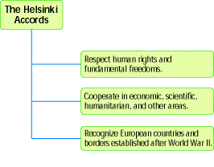

____ 11. Which of the following is a tenet of the Helsinki Accords?
a. | nationalism
b. | arms limitation
c. | economic, scientific, and humanitarian cooperation
d. | European borders existing before World War II

____ 12. Relations between the United States and Soviet Union cooled during the late 1970s because of the
a. | Soviet invasion of Afghanistan.
b. | signing of the SALT II treaty.
c. | election of Jimmy Carter as President.
d. | 1980 Summer Olympic Games in Moscow.

____ 13. What did Egypt agree to do in order to achieve peace with Israel?
a. | withdraw its troops from the Sinai Peninsula
b. | release all Israeli hostages held in Egypt
c. | have President Anwar el-Sadat step down
d. | formally recognize the nation of Israel

____ 14. To compensate for cutting taxes, President Reagan convinced Congress to
a. | balance the budget.
b. | cut spending on social programs.
c. | increase spending on defense programs.
d. | put more money into government regulatory programs.

____ 15. During his election campaign in 1988, George H.W. Bush promised not to
a. | raise taxes. | c. | cut funding for welfare programs.
b. | engage in foreign conflicts. | d. | increase the minimum retirement age.

____ 16. The proposed “Star Wars” program involved
a. | putting weapons in space.
b. | selling arms to other nations.
c. | increasing nuclear weapons production.
d. | attacking the Soviet Union before it could attack the United States.

____ 17. Gorbachev pursued glasnost and perestroika reforms in part because
a. | the war in Afghanistan had drained the nation’s resources.
b. | the Soviet Union had already demonstrated superior nuclear capability.
c. | food surpluses and production increases created stable economic conditions.
d. | Russian revolutionaries staged a coup to overthrow the communist government.

____ 18. Some conservatives believe that a large central government
a. | harms economic growth. | c. | undermines public welfare programs.
b. | promotes industrialization. | d. | encourages too much individual choice.

____ 19. The Supreme Court’s ruling in Engel v. Vitale
a. | legalized abortion. | c. | forbade religious teaching in schools.
b. | condemned homosexuality. | d. | overturned the Equal Rights Amendment.

____ 20. Ronald Reagan convinced many Americans that he would
a. | usher in a new era of prosperity.
b. | end the Cold War with the Soviet Union.
c. | use higher taxes to increase the public welfare.
d. | focus on practical action rather than on idealistic optimism.

Use the graph below to answer the following question.

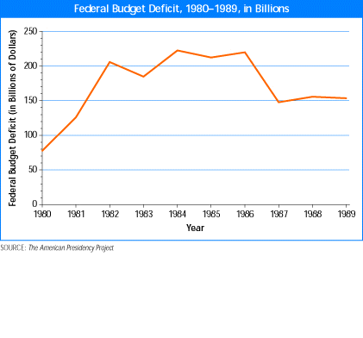

____ 21. What Reagan policy resulted in an increase in the federal budget deficit?
a. | supply-side economics | c. | increased defense spending
b. | deregulation | d. | increased spending on social programs

____ 22. “Reaganomics” emphasized
a. | tax cuts. | c. | defense reductions.
b. | social spending. | d. | regulation of industry.

____ 23. The federal government responded to the Savings and Loan crisis by
a. | cutting defense spending. | c. | balancing the federal budget.
b. | paying off the national debt. | d. | bailing out depositors at failed banks.

____ 24. A Nation at Risk reported on the
a. | rising threat of AIDS.
b. | coming crisis in Social Security.
c. | declining test scores of students.
d. | income gap between the rich and the poor.

Use the timeline to answer the following question.

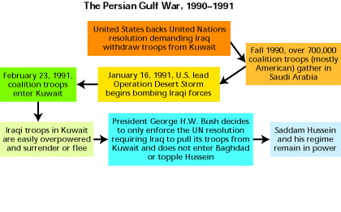

____ 25. Which of the following occurred after coalition troops entered Kuwait?
a. | UN passes a resolution demanding Iraqi troops leave Kuwait
b. | Saddam Hussein remains in power
c. | Iraqi forces are bombed during Operation Desert Storm
d. | Iraqi troops enter Kuwait to secure oil

____ 26. Why did the Bush Administration back the UN resolution calling for Hussein to withdraw from Kuwait?
a. | The United States had a protection treaty with Kuwait.
b. | The Bush Administration feared Hussein would invade Israel.
c. | The United States feared that Hussein would gain and use influence if he controlled Kuwaiti oil.
d. | President Bush supported the use of military force against Hussein only if he attempted to invade Saudi Arabia.

____ 27. The Reagan administration committed the United States to a
a. | massive arms buildup. | c. | policy of nonintervention.
b. | nuclear weapons freeze. | d. | withdrawal from the Cold War.

____ 28. Reagan supported rebellions in Afghanistan, Nicaragua, El Salvador, and Grenada to
a. | protect human rights. | c. | promote democratic governments.
b. | weaken the Soviet Union. | d. | undermine right-wing extremists.

____ 29. The START I treaty aimed to
a. | delay the Star Wars program.
b. | rebuild the former Soviet republics.
c. | end communist control of eastern Europe.
d. | reduce the number of nuclear weapons in the world.

____ 30. Which of the following symbolized the end of communism in Europe?
a. | the fall of the Berlin Wall
b. | the collapse of the Soviet Union
c. | the destruction of a statue of Stalin
d. | the summit between Gorbachev and Reagan

____ 31. The Iran-Contra affair violated the Reagan administration’s policy of refusing to
a. | negotiate with terrorists.
b. | engage the military in the Middle East.
c. | sell weapons outside the United States.
d. | fund revolutionary groups in other countries.

____ 32. The Bush administration cracked down on drug trafficking from
a. | Africa. | c. | Latin America.
b. | China. | d. | the Middle East.

____ 33. Congress tried to pressure South Africa into changing its apartheid system by
a. | suspending arms sales. | c. | withdrawing all investments.
b. | severing diplomatic ties. | d. | imposing economic sanctions.

____ 34. In 1990, Saddam Hussein invaded Kuwait to
a. | overthrow a ruthless dictator.
b. | launch a war against Saudi Arabia.
c. | take over the nation’s rich oil deposits.
d. | evict American forces from the Middle East.

____ 35. Which of the following best describes the 1991 Persian Gulf War?
a. | short, with few casualties | c. | long, with few American casualties
b. | short, with few American casualties | d. | long, with many casualties

Use the photograph and your knowledge of social studies to answer the following questions.

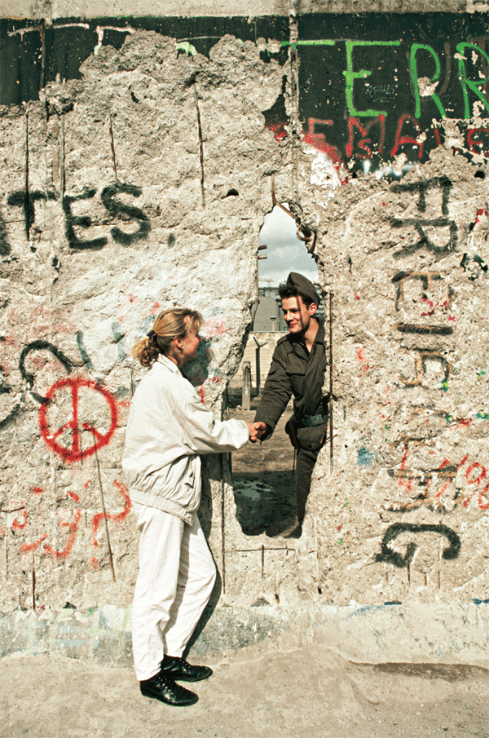

____ 36. What does the handshake between the soldier and civilian in this photograph symbolize?
a. | the Cold War | c. | unification of East and West Germany
b. | the break-up of the Soviet Union | d. | perestroika

____ 37. How do some scholars believe Ronald Reagan helped bring an end to the Cold War?
a. | Reagan’s policy of glasnost promoted peace.
b. | By limiting American military spending, Reagan forced the Soviets to do the same.
c. | Mikhail Gorbachev and Reagan negotiated the end of the Soviet Union by signing the START I Treaty.
d. | Reagan supported a massive arms buildup that hastened the collapse of the Soviet economy.

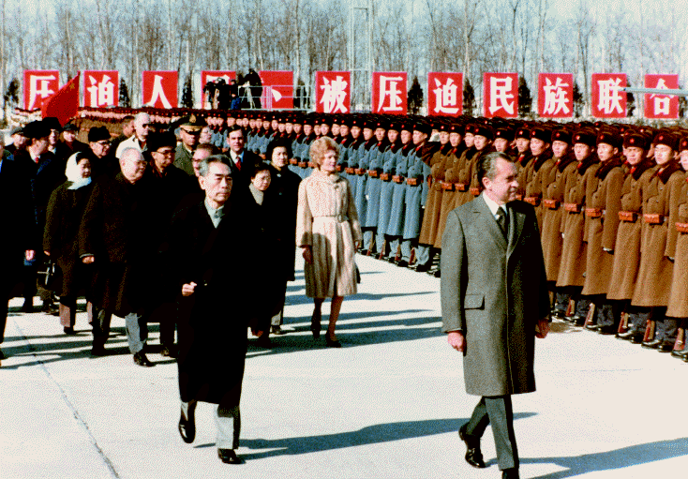

____ 38. What effect did Nixon’s visit have on relations between China and the United States, according to Zhou Enlai?
a. | The Nationalist Chinese government was exiled to the island of Taiwan.
b. | It bridged “the vastest ocean in the world, twenty-five years of no communication.”
c. | The People’s Republic of China was recognized by the United Nations.
d. | China and the Soviet Union became rivals for territory and diplomatic influence.

____ 39. President Nixon believed that normalizing relations with China would
a. | prolong the war in Vietnam.
b. | hurt American economic interests.
c. | damage efforts to democratize China.
d. | drive a wedge between China and the Soviet Union.

____ 40. SALT I
a. | encouraged China to enter the arms race.
b. | reduced tensions between the United States and the Soviet Union.
c. | ended the arms race between the United States and the Soviet Union.
d. | sparked a renewed effort on the part of the United States to stockpile missiles.

Richard M. Nixon to George H.W. Bush: The Second Part of the Cold War
Answer Section

MULTIPLE CHOICE

1. ANS: B PTS: 1 DIF: average
REF: M.604 | S.1052 | N.920 | O.796 | R.716
OBJ: M.18.1.3 | S.31.1.3 | R.22.1.3|O.24.1.3|N.27.1.3 TOP: history | Watergate

2. ANS: A PTS: 1 DIF: average
REF: M.608 | S.1056 | N.924 | O.800 | R.720
OBJ: M.18.2.1 | S.31.2.1 | R.22.2.1|O.24.2.1|N.27.2.1 TOP: history | Gerald Ford

3. ANS: C PTS: 1 DIF: average REF: M.599|S.1047|N.915|O.791|R.711
OBJ: M.18.1.1|S.31.1.1|R.22.1.1|O.24.1.1|N.27.1.1 TOP: culture | Nixon

4. ANS: A PTS: 1 DIF: average REF: M.601|S.1049|N.917|O.793|R.713
OBJ: M.18.1.3|S.31.1.3|R.22.1.3|O.24.1.3|N.27.1.3
TOP: impact of individual | Nixon | Supreme Court

5. ANS: D PTS: 1 DIF: average REF: M.605|S.1053|N.921|O.797|R.717
OBJ: M.18.1.3|S.31.1.3|R.22.1.3|O.24.1.3|N.27.1.3 TOP: political systems | Nixon

6. ANS: D PTS: 1 DIF: average REF: M.608|S.1056|N.924|O.800|R.720
OBJ: M.18.2.1|S.31.2.1|R.22.2.1|O.24.2.1| N.27.2.1 TOP: economics | Ford

7. ANS: A PTS: 1 DIF: average REF: M.608|S.1056|N.924|O.800|R.720
OBJ: M.18.2.1|S.31.2.1|R.22.2.1|O.24.2.1| N.27.2.1
TOP: impact of individual | Nixon's pardon

8. ANS: C PTS: 1 DIF: average REF: M.615|S.1063|N.931|O.807|R.727
OBJ: M.18.3.1|S.31.3.1|R.22.3.1|O.24.3.1| N.27.3.1 TOP: global interaction | Ford

9. ANS: B PTS: 1 DIF: average REF: M.616|S.1064|N.932|O.808|R.728
OBJ: M.18.3.1|S.31.3.1|R.22.3.1|O.24.3.1| N.27.3.1 TOP: global interaction | Afghanistan

10. ANS: D PTS: 1 DIF: average REF: M.618|S.1066|N.934|O.810|R.730
OBJ: M.18.3.2|S.31.3.2|R.22.3.2|O.24.3.2| N.27.3.2
TOP: impact of individual | Carter | Camp David

11. ANS: C PTS: 1 DIF: easy
REF: S.1063 | M.615 | N.931 | O.807 | R.727
OBJ: S.31.3.1 | M.18.3.1 | R.22.3.1| O.24.3.1| N.27.3.1
TOP: global interaction | Ford | Helsinki Accords

12. ANS: A PTS: 1 DIF: easy
REF: M.616 | S.1064 | N.932 | O.808 | R.728
OBJ: M.18.3.1 | S.31.3.1 | R.22.3.1|N.27.3.1|O.24.3.1
TOP: history | United States and Soviet Union

13. ANS: D PTS: 1 DIF: average
REF: M.617-8 | S.1065-6 | N.933-4 | O.809-10 | R.729–730
OBJ: M.18.3.3 | S.31.3.3 | R.22.3.3|N.27.3.3|O.24.3.3
TOP: global interaction | Camp David Accords

14. ANS: B PTS: 1 DIF: average
REF: M.633 | S.1081 | N.949 | O.825 | R.745
OBJ: M.19.2.1 | S.33.2.1 | R.23.2.1| O.25.2.1| N.28.2.1 TOP: economics | tax cuts

15. ANS: A PTS: 1 DIF: average
REF: M.635 | S.1083 | N.951 | O.827 | R.747
OBJ: M.19.2.3 | S.29.2.3 | R.23.2.3| O.25.2.3| N.28.2.3
TOP: impact of individual | George H.W. Bush

16. ANS: A PTS: 1 DIF: average
REF: M.640 | S.1088 | N.956 | O.832 | R.752
OBJ: M.19.3.1 | S.32.3.1 | R.23.3.1| O.25.3.1| N.28.3.1 TOP: technology | Star Wars program

17. ANS: A PTS: 1 DIF: average
REF: M.640 | S.1088 | N.956 | O.832 | R.752
OBJ: M.19.3.2 | S.29.3.2 | R.23.3.2| O.25.3.2| N.28.3.2
TOP: impact of individual | Mikhail Gorbachev

18. ANS: A PTS: 1 DIF: average REF: M.629|S.1077|N.945|O.821|R.741
OBJ: M.19.1.1|S.32.1.1|R.23.1.1|O.25.1.1| N.28.1.1 TOP: political system | economics

19. ANS: C PTS: 1 DIF: average REF: M.630|S.1078|N.946|O.822|R.742
OBJ: M.19.2.2|S.32.2.2|R.23.2.2|O.25.2.2| N.28.2.2 TOP: religion | Supreme Court

20. ANS: A PTS: 1 DIF: average REF: M.633|S.1081|N.949|O.825|R.744
OBJ: M.19.2.1|S.32.2.1|R.23.2.1|O.25.2.1| N.28.2.1 TOP: economics | Reagan

21. ANS: C PTS: 1 DIF: moderate REF: M.634|S.1082|N.950|O.826|R.746
OBJ: M.19.2.1|S.32.2.1|R.23.2.1|O.25.2.1| N.28.2.1 TOP: economics | budget deficit

22. ANS: A PTS: 1 DIF: average REF: M.633|S.1081|N.949|O.825|R.745
OBJ: M.19.2.1|S.32.2.1|R.23.2.1|O.25.2.1| N.28.2.1 TOP: economics | Reagan

23. ANS: D PTS: 1 DIF: average REF: M.634|S.1082|N.950|O.826|R.746
OBJ: M.19.2.1|S.32.2.1|R.23.2.1|O.25.2.1| N.28.2.1 TOP: economics | Savings and Loan crisis

24. ANS: C PTS: 1 DIF: average REF: M.637|S.1085|N.953|O.829|R.749
OBJ: M.19.2.3|S.32.2.3|R.23.2.3|O.25.2.3| N.28.2.3
TOP: art and literature | culture | education

25. ANS: B PTS: 1 DIF: moderate
REF: S.1095-6 | M.647-8 | N.963-4 | O.839-40 | R.759–760
OBJ: S.32.4.2 | M.19.4.2 | R.23.4.2| O.25.4.2| N.28.4.2
TOP: global interaction | Persian Gulf War

26. ANS: C PTS: 1 DIF: moderate
REF: M.647 | S.1095 | N.963 | O.839 | R.759
OBJ: M.19.4.2 | S.32.4.2 | R.23.4.2| O.25.4.2| N.28.4.2
TOP: global interaction | Persian Gulf War

27. ANS: A PTS: 1 DIF: average REF: M.639|S.1087|N.955|O.831|R.751
OBJ: M.19.3.1|S.32.3.1|R.23.3.1|O.25.3.1| N.28.3.1
TOP: global interaction | arms race | Reagan

28. ANS: B PTS: 1 DIF: average REF: M.640|S.1088|N.956|O.832|R.752
OBJ: M.19.3.1|S.32.3.1|R.23.3.1|O.25.3.1| N.28.3.1 TOP: global interaction | Reagan

29. ANS: D PTS: 1 DIF: average REF: M.641|S.1089|N.957|O.833|R.753
OBJ: M.19.3.1|S.32.3.1|R.23.3.1|O.25.3.1| N.28.3.1 TOP: power and conflict | START I

30. ANS: A PTS: 1 DIF: average REF: M.641|S.1089|N.957|O.833|R.753
OBJ: M.19.3.2|S.32.3.2|R.23.3.2|O.25.3.2| N.28.3.2 TOP: continuity and change | Berlin

31. ANS: A PTS: 1 DIF: average REF: M.644|S.1092|N.960|O.836|R.756
OBJ: M.19.3.3|S.32.3.3|R.23.3.3|O.25.3.3
TOP: power and conflict | Iran-Contra affair

32. ANS: C PTS: 1 DIF: average REF: M.645|S.1093|N.961|O.837|R.757
OBJ: M.19.4.1|S.32.4.1|R.23.4.1|O.25.4.1| N.28.4.1 TOP: history | Latin America

33. ANS: D PTS: 1 DIF: average REF: M.646|S.1094|N.962|O.838|R.758
OBJ: M.19.4.1|S.32.4.1|R.23.4.1|O.25.4.1| N.28.4.1 TOP: economics | apartheid

34. ANS: C PTS: 1 DIF: average REF: M.647|S.1095|N.963|O.839|R.759
OBJ: M.19.4.2|S.32.4.2|R.23.4.2|O.25.4.2| N.28.4.2 TOP: economics | Kuwait

35. ANS: B PTS: 1 DIF: average REF: M.649|S.1097|N.965|O.841R.761
OBJ: M.19.4.2|S.32.4.2|R.23.4.2|O.25.4.2| N.28.4.2
TOP: power and conflict | Persian Gulf War

36. ANS: C PTS: 1 DIF: moderate
REF: S.1089-91 | M.641-3 | N.957-59 | O.833-5 | R.753–755
OBJ: S.32.3.2 | M.19.3.2 | R.23.3.2| O.25.3.2| N.28.3.2 TOP: global interaction | Berlin Wall

37. ANS: D PTS: 1 DIF: moderate
REF: S.1089-91 | M.641-3 | N.957-59 | O.833-5 | R.753–755
OBJ: S.32.3.2 | M.19.3.2 | R.23.3.2| O.25.3.2| N.28.3.2
TOP: impact of individual | Ronald Reagan|Cold War

38. ANS: B PTS: 1 DIF: moderate
REF: S.1010 | M.562 | N.878 | O.754 | R.674
OBJ: S.29.5.2 | M.16.5.2 | R.20.5.2|O.22.5.2|N.25.5.2 TOP: global interaction | China

39. ANS: D PTS: 1 DIF: average REF: M.562 | S.1010 | R.674
OBJ: M.16.5.2 | S.29.5.2 | R.20.5.2|N.25.5.2|O.22.5.2 TOP: global interaction | Nixon | China

40. ANS: B PTS: 1 DIF: average
REF: M.562-563 | S.1010-1011 | R.674-675
OBJ: M.16.5.2 | S.29.5.2 | R.20.5.2|O.22.5.2|N.25.5.2 TOP: global interaction | SALT I

