Cold War Up To 1975 Review

Multiple Choice
Identify the choice that best completes the statement or answers the question.

____ 1. President Nixon’s Vietnamization policy emphasized that the United States must
a. | empower South Vietnamese forces to assume more combat duties.
b. | open trade relations with a unified Vietnam.
c. | defeat communism in Vietnam to preserve other countries.
d. | use any means necessary to end the war.

Use the chart and your knowledge of social studies to answer the following questions.

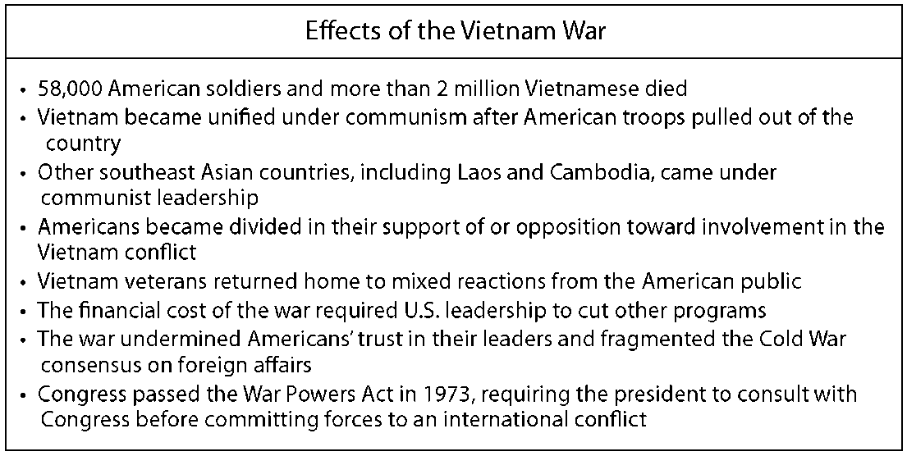

____ 2. What effect did the Vietnam War have on the American people?
a. | Vietnam veterans were hailed as heroes and given a warm welcome when they returned home from war.
b. | It undermined public trust in American leaders.
c. | It did not change.
d. | It gave Americans confidence that their leaders were making appropriate military decisions.

____ 3. What difference was seen in the reception of Vietnam veterans by the American public compared with the reception that veterans of World Wars I and II received?
a. | Vietnam veterans did not receive a warm welcome, whereas victory parades were held in response to the return of veterans from the world wars.
b. | Veterans of the World Wars were not welcomed warmly, whereas Vietnam veterans were hailed as heroes.
c. | Americans fully honored Vietnam veterans immediately following their return home.
d. | A memorial was erected in Washington, D.C., in honor of world war veterans, while victory parades were held in Vietnam veterans’ honor.

____ 4. After President Eisenhower withdrew his offer to fund the Aswan Dam, Egyptian President Nasser
a. | closed the Suez Canal.
b. | nationalized the Suez Canal.
c. | turned to the Soviet Union for the money.
d. | attacked the United States.

____ 5. Why was the Immigration and Nationality Act of 1965 necessary?
a. | Too many immigrants were coming to the United States each year.
b. | The United States did not have enough workers to support industry.
c. | Existing American immigration policies were discriminatory.
d. | The legislation setting immigration policy had expired.

____ 6. The Tet Offensive damaged American morale because it
a. | led to a popular uprising against the government of South Vietnam.
b. | demonstrated that the communists had not lost the will or ability to fight.
c. | the Vietcong succeeded in winning key victories against American troops.
d. | caused heavy casualties among American and South Vietnamese forces.

____ 7. President Nixon ordered the secret bombing of the Ho Chi Minh Trail in Cambodia to
a. | reduce the flow of communist supplies. | c. | protect Vietnamese civilians.
b. | stop the peace process. | d. | end the war.

____ 8. Between 1940 and 1960, more than 40 million Americans
a. | moved into new urban housing developments.
b. | helped rebuild older industrialized cities.
c. | returned to rural regions to redevelop the land.
d. | migrated to the suburbs.

____ 9. Which of the following contributed to a surge in postwar home construction?
a. | low inflation | c. | loans to war veterans
b. | foreign aid | d. | price controls

____ 10. The National Defense Education Act allocated federal funds to train
a. | soldiers. | c. | businessmen.
b. | politicians. | d. | scientists.

____ 11. Dr. Benjamin Spock
a. | developed a vaccine against polio.
b. | emphasized the importance of nurturing children.
c. | attracted millions to religious revivals around the nation.
d. | encouraged women to work outside the home.

____ 12. What happened during the Vietnamese election in 1956?
a. | Ngo Dinh Diem refused to participate.
b. | Ngo Dinh Diem won an overwhelming popular victory.
c. | Ho Chi Minh canceled the election.
d. | The United States intervened and installed Ngo Dinh Diem as president.

____ 13. What was one result of the Great Society?
a. | President Johnson’s popularity plummeted.
b. | The federal government shrank considerably.
c. | The lives of many underprivileged Americans improved.
d. | Poverty was eliminated in the United States.

____ 14. As the result of the Cuban Missile Crisis, Khrushchev
a. | developed radical new policies. | c. | became a more powerful leader.
b. | won many American supporters. | d. | declined in national politics.

____ 15. Television programs in the 1950s often
a. | dealt with real-life problems, such as illness, alcoholism, and depression.
b. | idealized families centered around the father as breadwinner and the mother as homemaker.
c. | gave equal air time to African American and other minority characters and stories.
d. | did not allow commercial advertising.

____ 16. The Marshall Plan generated economic growth by
a. | making home loans to war veterans.
b. | stimulating foreign demand for American products.
c. | prohibiting labor unions.
d. | funding the development of new technologies.

____ 17. Operation Rolling Thunder was a(n)
a. | strategy to regain control of the U.S. embassy in Saigon.
b. | sustained bombing campaign against North Vietnam.
c. | offensive designed to show that North Vietnam could still fight.
d. | plan to give South Vietnam greater military responsibility.

____ 18. General MacArthur chose what port city for a counterattack against North Korea?
a. | Inchon | c. | Pyngyang
b. | Seoul | d. | Pusan

____ 19. The Bay of Pigs invasion was an attempt to overthrow
a. | Fidel Castro. | c. | the Batista regime.
b. | the Kennedy administration. | d. | Nikita Kruschev

____ 20. Which of the following best describes the Vietcong’s war strategy?
a. | avoid any confrontation | c. | battle by day and rest at night
b. | fight small skirmishes | d. | engage in large-scale battles

____ 21. Who first spoke of the “iron curtain”?
a. | Joseph Stalin | c. | George Kennan
b. | Winston Churchill | d. | Harry Truman

____ 22. American soldiers used Agent Orange to
a. | kill as many Vietcong guerrillas as possible.
b. | deter villages from harboring guerrillas.
c. | disrupt the enemy’s food supply.
d. | detect Vietcong booby traps.

____ 23. Kennedy prevented completion of missile bases in Cuba by approving a
a. | naval blockade. | c. | diplomatic treaty.
b. | trade boycott. | d. | military invasion.

____ 24. By the end of 1965, most American soldiers in Vietnam
a. | had been drafted. | c. | were volunteers.
b. | had not seen any fighting. | d. | refused to fight.

Use the image below to answer the question.

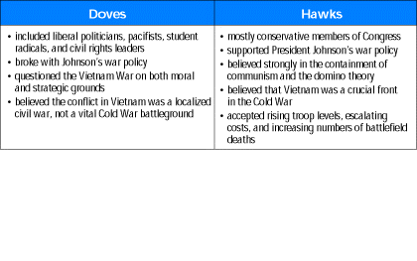

____ 25. What was the main difference between Doves and Hawks regarding U.S. presence in Vietnam?
a. | Doves believed that the United States military should have a strong presence in Vietnam, while Hawks did not.
b. | Doves believed that the Vietnam conflict was a localized civil war and did not agree with Johnson’s war policy, whereas Hawks supported Johnson’s policy and believed Vietnam was a crucial front in the Cold War.
c. | Doves accepted the rising troop levels, escalating costs, and the increasing number of battlefield deaths, while Hawks questioned the war on both moral and strategic grounds.
d. | Doves agreed with President Johnson’s war policy, but Hawks believed Johnson’s policy was wrong.

____ 26. To eliminate deferment abuses, the Selective Service system
a. | allowed some men to burn their draft cards.
b. | adopted a lottery.
c. | recruited more heavily among working class and poor people.
d. | put local draft boards in charge of selection.

____ 27. NATO and the Warsaw Pact were examples of
a. | failed attempts to make peace.
b. | military aggression during the Cold War.
c. | military alliances made for “collective security.”
d. | efforts to fight communism without bloodshed.

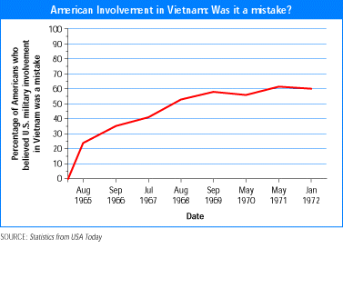

____ 28. What 1968 event caused U.S. military leaders to be concerned that a quick end to the war was not possible?
a. | President Johnson announced that he would not run for another term as president.
b. | The Students for a Democratic Society was founded.
c. | Eugene McCarthy made a strong showing in the New Hampshire primary.
d. | The U.S. military suffered a major strategic blow in the Tet Offensive.

____ 29. In 1970, President Nixon tried to break the stalemate in the peace process by
a. | helping the Khmer Rouge seize power in Cambodia.
b. | sending economic aid to the Cambodian government.
c. | pulling U.S. forces out of Cambodia.
d. | ordering a ground attack on Vietcong bases in Cambodia.

Use the image below to answer the question.

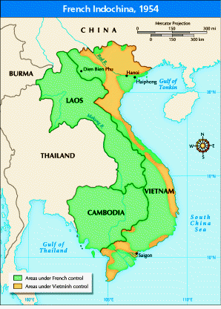

____ 30. What happened at Dien Bien Phu in 1954?
a. | Ho Chi Minh established the headquarters for the Vietminh.
b. | Eisenhower delivered a speech about the domino theory.
c. | The Vietminh laid siege to a garrison of French troops who then surrendered.
d. | The French signed the Geneva Accords.

____ 31. The Gulf of Tonkin Resolution allowed President Johnson to
a. | declare war against North Vietnam without asking Congress.
b. | take all necessary measures to defend against armed attacks on U.S. forces.
c. | use the USS Maddox to control the seas around South Vietnam.
d. | send economic aid to South Vietnam.

____ 32. Rock-and-roll music
a. | grew out of a subversive communist movement.
b. | attacked traditional religious authority.
c. | became a symbol of youth culture.
d. | developed as a southern alternative to rhythm and blues music.

____ 33. In order to try to gain control over West Berlin, the Soviet Union
a. | threatened the section of the city with troops and tanks.
b. | set up a total blockade cutting off that section of the city.
c. | operated a massive airlift to bring in needed supplies.
d. | went to the United Nations and demanded control of that section of the city.

____ 34. The Alliance for Progress provided what kind of assistance to Latin American countries?
a. | medical | c. | educational
b. | economic | d. | military

____ 35. How did the American public view General MacArthur after President Truman fired him?
a. | They were angry that he had miscalculated in the war.
b. | They still saw him as a hero.
c. | They thought he was too old to still be on active duty.
d. | They thought he was a traitor.

____ 36. What occurred at My Lai?
a. | U.S. forces suffered a crippling defeat.
b. | Vietnam became unified under one flag.
c. | Vietcong guerrillas surrendered.
d. | American soldiers killed hundreds of Vietnamese civilians.

____ 37. What did President Kennedy’s domestic agenda primarily fight?
a. | Republicans | c. | communism
b. | unemployment | d. | poverty

____ 38. What effect did the Cold War have on the American space program?
a. | The need for nuclear weapons led to less sophisticated rocket technology.
b. | High levels of military spending deterred scientific research.
c. | American and Soviet scientific cooperation lessened political tension.
d. | Competition with the Soviet Union spurred American space missions.

____ 39. What issue led to the construction of the Berlin Wall?
a. | new American intervention in Europe
b. | Soviet attempts to control all of Germany
c. | the removal of U.S. troops from Berlin
d. | America’s refusal to recognize a divided Germany

____ 40. The rise of the car culture led to the
a. | spread of fast-food restaurants and drive-in movie theaters.
b. | increasing dependence on mass transportation.
c. | revitalization of older city neighborhoods.
d. | decline of shopping malls.

____ 41. The CIA participated in the Cold War by
a. | helping design efficient weapons systems.
b. | carrying out secret operations in other countries.
c. | spying on the Soviet Union.
d. | helping the President determine foreign policy.

____ 42. Julius and Ethel Rosenberg were charged, convicted, and executed specifically for
a. | being members of the communist party.
b. | violating the Smith Act.
c. | passing secrets about nuclear science to the Soviets.
d. | being subversives and disloyal Americans.

____ 43. What led to Senator McCarthy’s downfall?
a. | the broadcast of the McCarthy hearings on television
b. | revelations that he was a communist himself
c. | the uncovering of financial irregularities in his Senate campaign
d. | the discovery that some of the people he had accused were innocent

____ 44. One goal of the Marshall Plan was to
a. | make Germany pay costs for all the destruction it had caused in Europe.
b. | send troops to help European countries fight communism.
c. | make European countries strong enough to start buying American goods.
d. | give Europeans access to higher education in the United States

____ 45. What impact did the Korean War have on U.S. budgets?
a. | The budget for the military was temporarily increased, but then reduced later on.
b. | Military spending increased and became a larger proportion of future budgets.
c. | More money was allocated for diplomacy and peacekeeping efforts.
d. | Military spending went down because of increased U.N. involvement in world affairs.

____ 46. What happened on September 2, 1949 that caused a sudden change in U.S.-Soviet relations?
a. | North Korea invaded South Korea.
b. | The military alliance known as SEATO was formed.
c. | The Soviet Union set off an atomic bomb.
d. | The Soviet Union launched a satellite into space.

Use the table and your knowledge of social studies to answer the following questions.

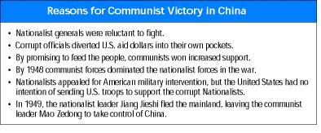

____ 47. Which of the following is a reason for communist victory in China?
a. | The communists refused to feed the people.
b. | The Nationalists were reluctant to fight.
c. | The United States sent U.S. troops to aid the Nationalists.
d. | Mao Zedong fled the mainland.

____ 48. Why did the United States send several billion dollars to aid the Nationalists in China?
a. | to aid the communists in the fight for power
b. | because leaders feared that a Nationalist defeat would create a communist superpower
c. | to increase the training of Nationalist generals
d. | to help the Nationalists fight corruption

Use the timeline and your knowledge of social studies to answer the following questions.

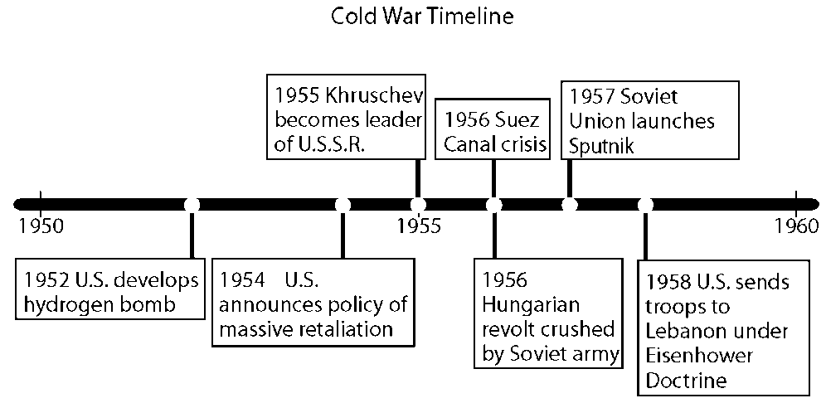

____ 49. What was the Eisenhower Doctrine?
a. | The United States would liberate the countries behind the iron curtain.
b. | The United States would use force to help any Middle Eastern nation threatened by communism.
c. | The United States would recognize the People’s Republic of China.
d. | The United States would nationalize the Suez canal.

____ 50. As a result of the Nuclear Test Ban Treaty,
a. | the Soviet Union ended all nuclear testing.
b. | nearly forty countries ended aboveground nuclear tests.
c. | relations between the United States and the Soviet Union worsened.
d. | the United States and the Soviet Union ceased to communicate.

____ 51. Kennedy’s military policies encouraged more funding for
a. | nuclear weapons. | c. | diplomatic solutions.
b. | the Special Forces. | d. | the Secret Service.

____ 52. How did the sexual revolution of the 1960s and 1970s affect American society?
a. | Teenage marriages increased. | c. | Individuals talked openly about sex.
b. | Sexually transmitted diseases declined. | d. | Divorce rates decreased.

____ 53. The second wave of feminism differed from the first wave because modern women wanted
a. | full equality with men, not just the right to vote.
b. | superiority over the men in their lives.
c. | voting rights, as well as full equality.
d. | all jobs to be given to women.

Use the chart below to answer the question(s).

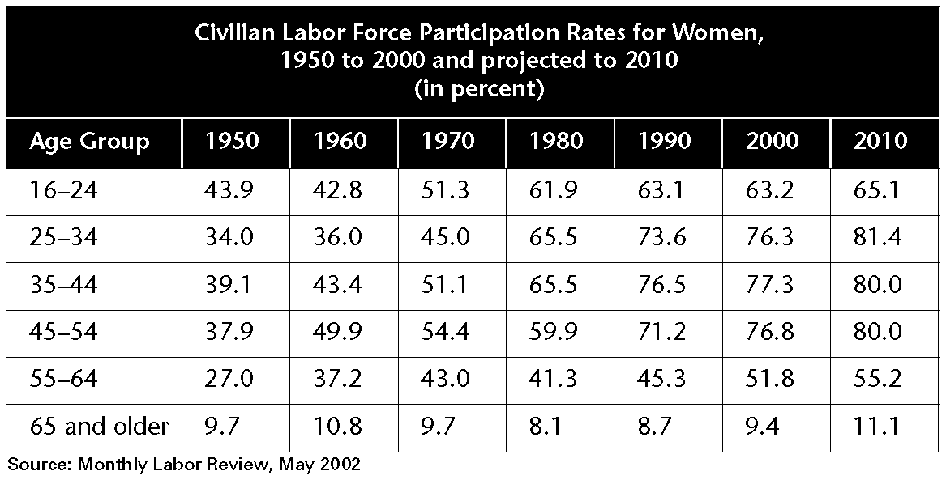

____ 54. Which of the following factors explains the general pattern in women’s participation in the labor force?
a. | As women’s roles have expanded, more women have entered the workforce.
b. | As opposition to women’s rights increased, less women joined the workforce.
c. | As baby boomers age, fewer people are working past age 65 than ever before.
d. | The women’s rights movement has led to fewer women taking low-paying jobs.

____ 55. Which event helped create the counterculture of the 1960s and 1970s?
a. | Great Depression | c. | Vietnam War
b. | World War II | d. | Woodstock

____ 56. Which defining characteristic of the counterculture provided the foundation for the various rights movements that followed it?
a. | protest | c. | communes
b. | drug use | d. | youthfulness

____ 57. The Cuyahoga River in Cleveland, Ohio, helped promote the environmental movement because
a. | it was the site of the first Earth Day activities.
b. | pollutants on its surface caught fire and attracted media attention.
c. | Rachel Carson was born there and it was the sight of her novel.
d. | it was the birthplace of the Sierra Club and the Wilderness Society.

____ 58. The purpose of the first Earth Day event on April 22, 1970, was to
a. | celebrate spring. | c. | raise money for the Superfund.
b. | plant trees and flowers. | d. | protest environmental problems.

Use the image below to answer the question.

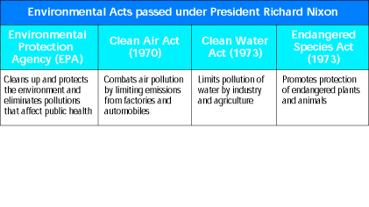

____ 59. Which act or agency shown on the chart actively protects rare plants and animals?
a. | Environmental Protection Agency | c. | Clean Water Act
b. | Clean Air Act | d. | Endangered Species Act

____ 60. Industrial pollution had become a problem in the middle of the twentieth century partly because few people had anticipated
a. | environmental problems. | c. | governmental regulations.
b. | the rapid growth of industry. | d. | protests and activism.

Cold War Up To 1975 Review
Answer Section

MULTIPLE CHOICE

1. ANS: A PTS: 1 DIF: average
REF: M.553 | S.1001 | N.869 | O.745 | R.665
OBJ: M.16.4.1 | S.29.4.1 | R.20.4.1|N.25.4.1|O.22.4.1 TOP: impact of individual | Nixon

2. ANS: B PTS: 1 DIF: moderate
REF: S.1007 | M.559 | N.875 | O.751 | R.671
OBJ: S.29.4.3 | M.16.4.3 | R.20.4.3|N.25.4.3|O.22.4.3 TOP: power and conflict | Vietnam War

3. ANS: A PTS: 1 DIF: moderate
REF: S.1007 | M.559 | N.875 | O.751 | R.671
OBJ: S.29.4.3 | M.16.4.3 | R.20.4.3|N.25.4.3|O.22.4.3

4. ANS: B PTS: 1 DIF: average
REF: S.863 | M.415 | N.731 | O608 | R.527
OBJ: S.25.3.2 | M.12.3.2 | R.16.3.2 | N.21.3.2 | O.18.3.2 TOP: global interaction | Suez Canal

5. ANS: C PTS: 1 DIF: average
REF: M.522-3 | S.970-1 | N.838-9 | O.714-5 | R.634–5
OBJ: M.15.3.3 | S.28.3.3 | R.19.3.3 | N.24.3.3 | O.21.3.3 TOP: history | immigration

6. ANS: B PTS: 1 DIF: average REF: M.547 | S.995 | R.659
OBJ: M.16.3.2 | S.29.3.2 | R.20.3.2|O.22.3.2|N.25.3.2 TOP: power and conflict | Tet Offensive

7. ANS: A PTS: 1 DIF: average REF: M.553 | S.1001 | R.665
OBJ: M.16.4.1 | S.29.4.1 | R.20.4.1|N.25.4.1|O.22.4.1 TOP: power and conflict | Cambodia

8. ANS: D PTS: 1 DIF: average
REF: S.888 | M.440 | N.756 | O.632 | R.552
OBJ: S.26.2.1 | M.13.2.1 | R.17.2.1 | N.22.2.1 | O.19.2.1 TOP: economics | history | post-WWII

9. ANS: C PTS: 1 DIF: average
REF: S.884 | M.436 | R.548 | O.628 | N.752
OBJ: S.26.1.3 | M.13.1.3 | R.17.1.3 | N.22.1.3 | O.19.1.3 TOP: economics | home construction

10. ANS: D PTS: 1 DIF: moderate
REF: S.894 | M.446 | R.558 | O.638 | N.762
OBJ: S.26.2.2 | M.13.2.2 | R.17.2.2 | N.22.2.2 | O.19.2.2 TOP: history | education

11. ANS: B PTS: 1 DIF: average
REF: S.897 | M.449 | N.765 | O.641 | R.561
OBJ: S.26.3.2 | M.13.3.2 | R.17.3.2 | N.22.3.2 | O.19.3.2
TOP: science | culture | Dr. Benjamin Spock

12. ANS: A PTS: 1 DIF: average REF: M.535 | S.983 | R.647
OBJ: M.16.1.2 | S.29.1.2 | R.20.12|N.25.1.2|O.22.1.2 TOP: power and conflict | Vietnam

13. ANS: C PTS: 1 DIF: average
REF: M.521 | S.969 | R.632 | N.838 | O.713
OBJ: M.15.3.3 | S.28.3.3 | R.19.3.3 | N.24.3.3 | O.21.3.3
TOP: culture | change and continuity | Great Society

14. ANS: D PTS: 1 DIF: easy
REF: M.508 | S.956 | N.824 | O.700 | R.620
OBJ: M.15.1.2 | S.28.1.2 | R.19.1.2 | N.24.1.2 | O.21.1.2 TOP: history | power and conflict

15. ANS: B PTS: 1 DIF: average REF: M.452 | S.900 | R.564
OBJ: M.13.3.2 | S.26.3.2 | R.17.3.2 | N.22.3.2 | O.19.3.2 TOP: culture | technology | television

16. ANS: B PTS: 1 DIF: average
REF: S.884 | M.436 | R.548 | O.628 | N.752
OBJ: S.26.1.3 | M.13.1.3 | R.17.1.3 | N.22.1.3 | O.19.1.3 TOP: history | Marshall Plan

17. ANS: B PTS: 1 DIF: average
REF: M.537 | S.985 | N.853 | O.729 | R.649
OBJ: M.16.2.1 | S.29.2.1 | R.20.2.1 |N.25.2.1|O.22.2.1
TOP: power and conflict | Operation Rolling Thunder

18. ANS: A PTS: 1 DIF: average
REF: S.855 | M.407 | N.723 | O.600 | R.519
OBJ: S.25.2.2 | M.12.2.2 | R.16.2.2 | N.21.2.2 | O.18.2.2 TOP: impact of individual | Korea

19. ANS: A PTS: 1 DIF: average
REF: M.508 | S.956 | R.620 | N.825 | O.700
OBJ: M.15.1.2 | S.28.1.2 | R.19.1.2 | N.24.1.3 | O.21.1.3 TOP: global interaction | Cuba

20. ANS: B PTS: 1 DIF: average REF: M.541 | S.989 | R.653
OBJ: M.16.2.3| S.29.23 | R.20.2.3|N.25.2.3|O.22.2.3 TOP: power and conflict | Vietcong

21. ANS: B PTS: 1 DIF: average
REF: S.848 | M.400 | N.516 | O.592 | R.512
OBJ: S.25.1.2 | M.12.1.2 | R.16.1.2 | N.21.1.2 | O.18.1.2 TOP: impact of individual | Churchill

22. ANS: C PTS: 1 DIF: average REF: M.538 | S.986 | R.650
OBJ: M.16.2.2 | S.29.2.2 | R.20.2.2|N.25.2.2|O.22.2.2
TOP: power and conflict | environment | Agent Orange

23. ANS: A PTS: 1 DIF: average
REF: M.508 | S.956 | R.620 | N.825 | O.700
OBJ: M.15.1.2 | S.28.1.2 | R.19.1.2 | N.24.1.2 | O.21.1.2
TOP: power and conflict | Cuban Missile Crisis

24. ANS: A PTS: 1 DIF: average REF: M.544 | S.992 | R.656
OBJ: M.16.3.1 | S.29.3.1| R.20.3.1|N.25.3.1|O.22.3.1
TOP: continuity and change | power and conflict | Vietnam

25. ANS: B PTS: 1 DIF: moderate
REF: S.991 | M.543 | N.859 | O.735 | R.655
OBJ: S.29.2.3 | M.16.2.3 | R.20.2.3|N.25.2.3|O22.2.3 TOP: power and conflict | Vietnam

26. ANS: B PTS: 1 DIF: average REF: M.545 | S.993 | R.657
OBJ: M.16.3.1 | S.29.3.1 | R.20.3.1|N.25.3.1|O.22.3.1
TOP: power and conflict | Vietnam War | draft

27. ANS: C PTS: 1 DIF: average
REF: S.852 | M.404 | N.720 | O.596 | R.516
OBJ: S.25.1.3 | M.12.1.3 | R.16.1.3 | N.21.1.3 | O.18.1.3 TOP: global interaction | alliances

28. ANS: D PTS: 1 DIF: moderate
REF: S.995 | M.547 | N.863 | O.739 | R.659
OBJ: S.29.3.2 | M.16.3.2 | R.20.3.2|N.25.3.2|O.22.3.2 TOP: power and conflict | Tet Offensive

29. ANS: D PTS: 1 DIF: average REF: M.553 | S.1001 | R.665
OBJ: M.16.4.1 | S.29.4.1 | R.20.4.1|N.25.4.1|O.22.4.1
TOP: impact of individual | Nixon | Vietnam

30. ANS: C PTS: 1 DIF: easy
REF: S.982 | M.534 | N.850 | O.726 | R.646
OBJ: S.29.1.1 | M.16.1.1 | R.20.1.1|N.25.1.1|O.22.1.1 TOP: history | Vietnam

31. ANS: B PTS: 1 DIF: average
REF: M.536 | S.984 | N.852 | O.728 | R.648
OBJ: M.16.1.3 | S.29.1.3 |R.20.1.3 |N.25.1.3 |O.22.1.3
TOP: power and conflict | Gulf of Tonkin Resolution

32. ANS: C PTS: 1 DIF: average REF: M.453 | S.901 | R.565
OBJ: M.13.3.3 | S.26.3.3 | R.17.3.3 | N.22.3.3 | O.19.3.3 TOP: culture | music | rock-and-roll

33. ANS: B PTS: 1 DIF: average
REF: S.850 | M.402 | N.718 | O.595 | R.514
OBJ: S.25.1.3 | M.12.1.3 | R.16.1.3 | N.21.1.3 | O.18.1.3 TOP: global interaction | Soviet Union

34. ANS: B PTS: 1 DIF: average
REF: M.507-8 | S.955-6 | N.823-4 | O.699-700 | R.619–20
OBJ: M.15.1.1 | S.28.1.1 | R.19.1.1 | N.24.1.1 | O.21.1.1
TOP: history | economics | global interaction

35. ANS: B PTS: 1 DIF: average
REF: S.858 | M.410 | N.726 | O.602 | R.522
OBJ: S.25.2.2 | M.12.2.2 | R.16.2.2 | N.21.2.2 | O.18.2.2 TOP: impact of individual | MacArthur

36. ANS: D PTS: 1 DIF: average REF: M.555 | S.1003 | R.667
OBJ: M.16.4.2 | S.29.4.2 | R.20.4.2|O.22.4.2|N.25.4.2 TOP: power and conflict | My Lai

37. ANS: D PTS: 1 DIF: challenging
REF: M.512-3 | S.960-1 | N.828-9 | O.704-5 | R.620–1
OBJ: M.15.2.1 | S.28.2.1 | R.19.2.1 | N.24.2.1 | O.21.2.1 TOP: history | economics

38. ANS: D PTS: 1 DIF: average
REF: M.513 | S.961 | R.625 | N.830 | O.705
OBJ: M.16.2.1 | S.29.2.1 | R.20.2.1 | N.24.2.1 | O.21.2.1
TOP: global interaction | space program | Cold War

39. ANS: D PTS: 1 DIF: average
REF: M.510 | S.958 | R.622 | N.827 | O.702
OBJ: M.15.1.3 | S.28.1.3 | R.19.1.3 | N.24.1.3 | O.21.1.3 TOP: political systems | Berlin Wall

40. ANS: A PTS: 1 DIF: average
REF: S.889 | M.441 | N.757 | O.633-4 | R.553
OBJ: S.26.2.2 | M.13.2.2 | R.17.2.2 | N.22.2.2 | O.19.2.2 TOP: culture | technology | post-WWII

41. ANS: B PTS: 1 DIF: average
REF: S.865 | M.417 | N.733 | O.609 | R.529
OBJ: S.25.3.3 | M.12.3.3 | R.16.3.3 | N.21.3.3 | O.18.3.3 TOP: history | Cold War

42. ANS: C PTS: 1 DIF: average
REF: S.873 | M.825 | N.741 | O.617 | R.537
OBJ: S.25.4.2 | M.12.4.2 | R.16.4.2 | N.21.4.2 | O.18.4.2
TOP: power and conflict | political systems | Communism

43. ANS: A PTS: 1 DIF: average
REF: S.875 | M.427 | N.743 | O.619 | R.539
OBJ: S.25.4.3 | M.12.4.3 | R.16.4.3 | N.21.4.3 | O.18.4.3
TOP: impact of individual | technology | McCarthy | Communism

44. ANS: C PTS: 1 DIF: average
REF: S.850 | M.402 | N.718 | O.594 | R.514
OBJ: S.25.1.1 | M.12.1.1 | R.16.1.1 | N.21.1.1 | O.18.1.1 TOP: economics | Marshall Plan

45. ANS: B PTS: 1 DIF: average
REF: S.859 | M.411 | N.727 | O.603 | R.523
OBJ: S.25.2.3 | M.12.2.3 | R.16.2.3 | N.21.2.3 | O.18.2.3 TOP: economics | Korea

46. ANS: C PTS: 1 DIF: average
REF: S.860 | M.412 | N.728 | O.604 | R.524
OBJ: S.25.1.1 | M.12.1.1 | R.16.1.1 | N.21.1.1 | O.18.1.1 TOP: technology | Soviet Union

47. ANS: B PTS: 1 DIF: easy
REF: S.854 | M.406 | N.722 | O.598 | R.518
OBJ: S.25.2.1 | M.12.2.1 | R.16.2.1 | N.21.2.1 | O.18.2.1
TOP: power and conflict | Communist China

48. ANS: B PTS: 1 DIF: moderate
REF: S.854 | M.406 | N.722 | O.598 | R.518
OBJ: S.25.2.1 | M.12.2.1 | R.16.2.1 | N.21.2.1 | O.18.2.1
TOP: global interaction | Nationalist support

49. ANS: B PTS: 1 DIF: easy
REF: S.864-5 | M.416-7 | N.732-3 | O.608-9 | R.528–529
OBJ: S.25.3.3 | M.12.3.3 | R.16.3.3 | N.21.3.3 | O.18.3.3 TOP: history | World War II

50. ANS: B PTS: 1 DIF: average
REF: M.508 | S.956 | N.824 | O.702 | R.620
OBJ: M.15.1.2 | S.28.1.2 | R.19.1.2 | N.24.1.2 | O.21.1.2
TOP: history | power and conflict | global interaction

51. ANS: B PTS: 1 DIF: average
REF: M.504 | S.952 | R.616 | O.696 | N.821
OBJ: M.15.1.1 | S.28.1.1 | R.19.1.1 | N.24.1.1 | O.21.1.1
TOP: history | power and conflict | Kennedy

52. ANS: C PTS: 1 DIF: average
REF: M.571 | S.1019 | N.887 | O.763 | R.683
OBJ: M.17.1.3 | S.30.1.3 | R.21.1.3|N.26.1.3|O.23.1.3 TOP: culture | sexual revolution

53. ANS: A PTS: 1 DIF: average
REF: M.574 | S.1022 | N.890 | O.766 | R.686
OBJ: M.17.2.2 | S.30.2.2 | R.21.2.2|N.26.2.2|O.23.2.2 TOP: history | women’s rights

54. ANS: A PTS: 1 DIF: average
REF: M.578 | S.1026 | N.894 | O.770 | R.690
OBJ: M.17.2.3 | S.30.2.3 | R.21.2.3|N.26.2.3|O.23.2.3 TOP: economics | women in labor force

55. ANS: C PTS: 1 DIF: average REF: M.570 | S.1018 | R.682
OBJ: M.17.1.1 | S.30.1.1 | R.21.1.1|N.26.1.1|O.23.1.1 TOP: culture | Vietnam War

56. ANS: A PTS: 1 DIF: average REF: M.573 | S.1021 | R.685
OBJ: M.17.1.3 | S.30.1.3 | R.21.1.3|N.26.1.3|O.23.1.3 TOP: power and conflict | counterculture

57. ANS: B PTS: 1 DIF: average REF: M.587 | S.1035 | R.699
OBJ: M.17.4.1 | S.30.4.1 | R.21.4.1|N.26.4.1|O.23.4.1 TOP: environment | Cleveland

58. ANS: D PTS: 1 DIF: average REF: M.587 | S.1035 | R.699
OBJ: M.17.4.1 | S.30.4.1 | R.21.4.1N.26.4.1|O.23.4.1 TOP: environment | Earth Day

59. ANS: D PTS: 1 DIF: easy
REF: S.1036 | M.588 | N.904 | O.780 | R.700
OBJ: S.30.4.2 | M.17.4.2 | R.21.4.2|N.26.4.2|O.23.4.2
TOP: environment | Endangered Species Act

60. ANS: A PTS: 1 DIF: average
REF: M.587 | S.1035 | N.903 | O.779 | R.699
OBJ: M.17.4.1 | S.30.4.1 | R.21.4.1|N.26.4.1|O.23.4.1 TOP: environment | industrialization

