Alaska Geography Unit: Mapping Alaska
Directions: Use Internet Explorer to navigate to http://education.nationalgeographic.com/education/mapping/interactive-map/?ar_a=1 . Once you reach this website your screen should look like the one below.

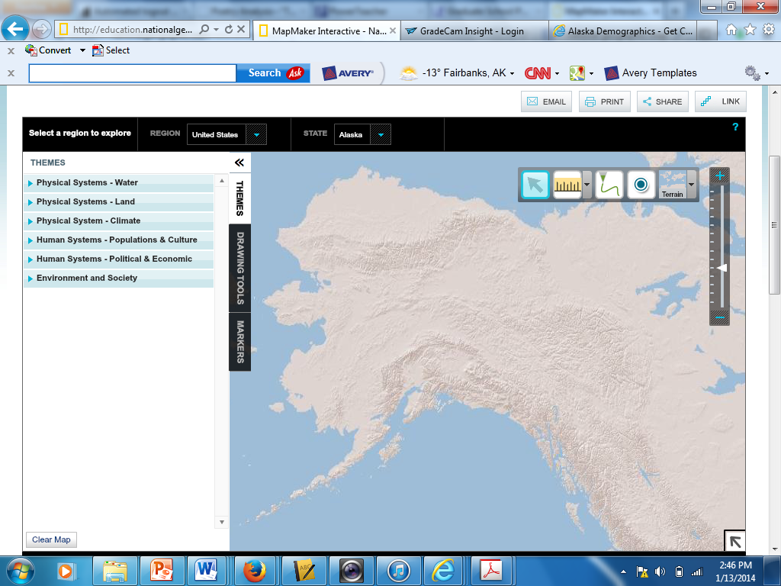
Upon reaching the map making interactive program you will need to select your region and state.
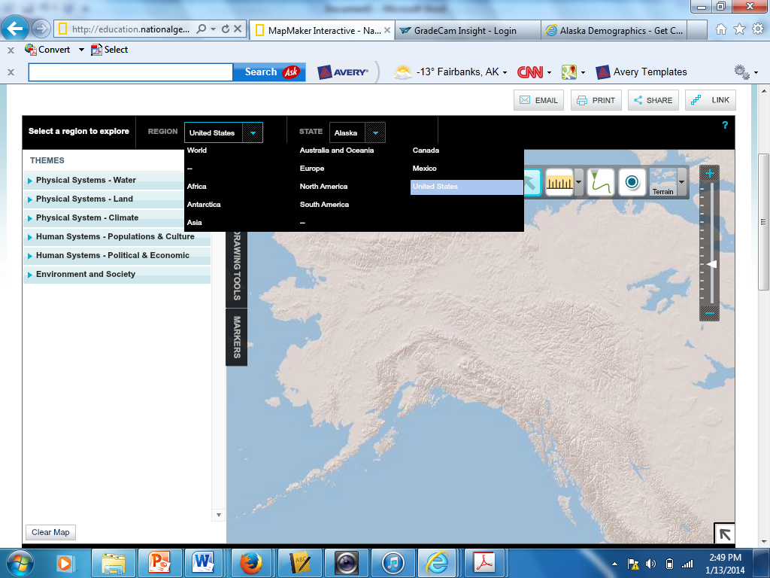
Pick Alaska!
You will also need to select Alaska as the primary state that you are planning on mapping.
Once you have narrowed down your scope to the state of Alaska, you must pick the type of map you will use to map the required features of Alaska.
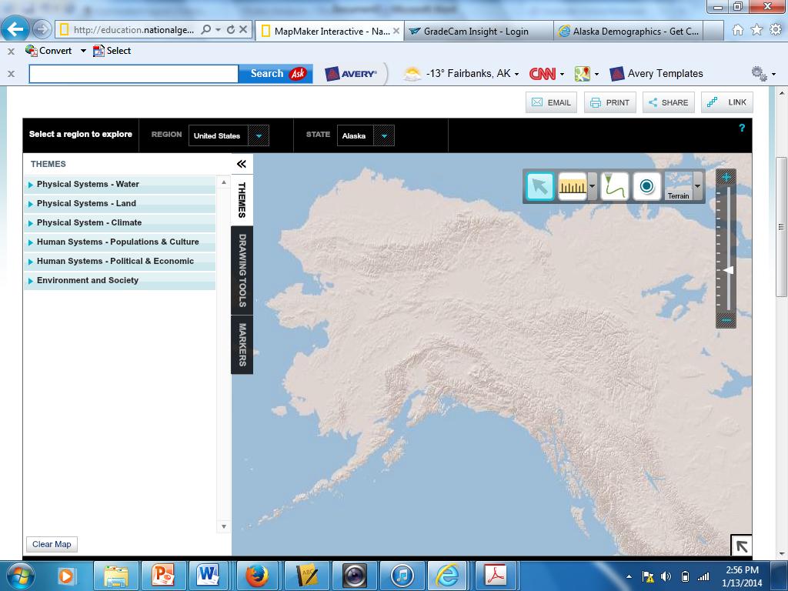
Choose Terrain Map
When mapping Mountains and Points of Interest you may use the markers tool, where you can drag and drop the symbols for each section. However you must use the drawing tools section to label these symbols after you have used the markers. 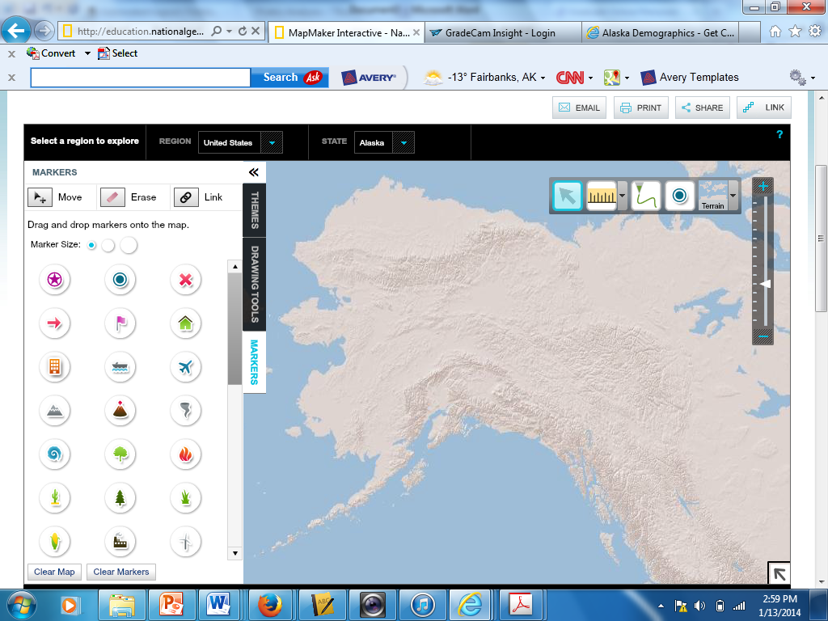
Markers

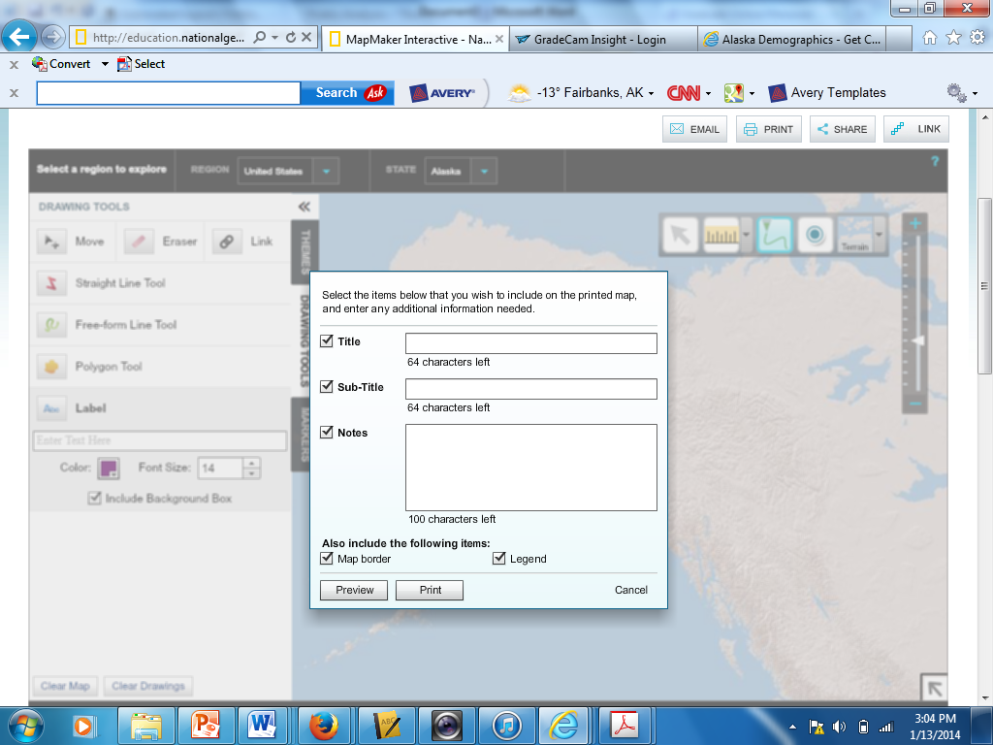
Drawing
Tools
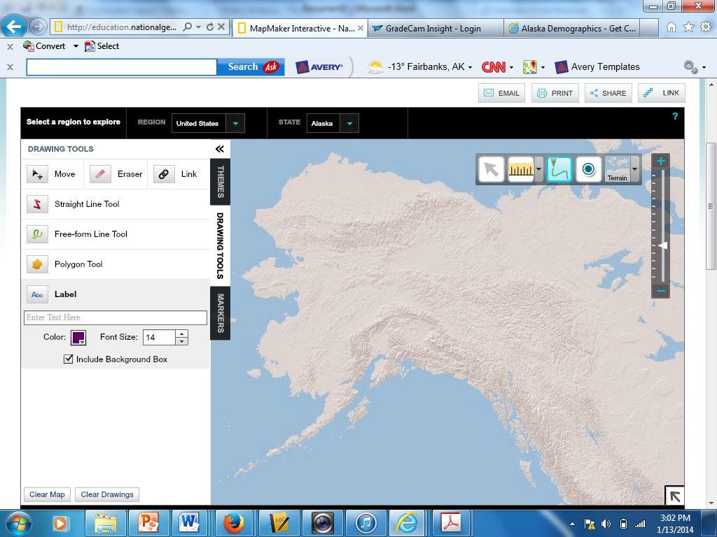
Print
Once you have completed all of the maps you are assigned to create you must print them individually and staple them as a packet. Please use the print function within the program, not going to file, print.
Map Project Directions

- Use the Terrain maps to create 7 separate maps. Each map should be labeled in order to represent the physical features/ points of interest you are trying to represent. The following maps should be included in your assignment:
  - Mountain ranges
  - Peninsulas
  - Islands and Archipelagos
  - Bodies of Water
  - Southeast Alaska Waterways
  - Rivers
  - Major Communities
- When you are completely finished with your maps, put them in the above order staple them into a packet and turn them into the box.
- This assignment is due by the end of class on (Wed for periods 5) (Thursday for periods 1 & 3)
See attached label sheet to know which features/points of interest you are supposed to label. Please ask for help if you are having trouble completing this assignment.

Each map is worth 12.5 points and an additional 12.5 points will be rewarded for following directions! Total points = 100 points.

